**Project 1: Voice activated Mask with LED- grid**

**Material list.**

**Tools:**

Solder

Soldering iron

Fabric Glue or a Sewing Kit

Safety goggles

Tape

Plyers

**Optional Useful Stuff:**

A heat shrink

A digital Multimeter

A soldering mat

Thermometer

**The Parts**

Led matrix 8x8 WS2812B

Microphone max4466

Arduino Nano

330Ω resistor

24 Gauge wire

Heat shrinks

5V Powerbank oder Lithium Batteriepack

KCD1 Switch

**Physical circuit diagram:**

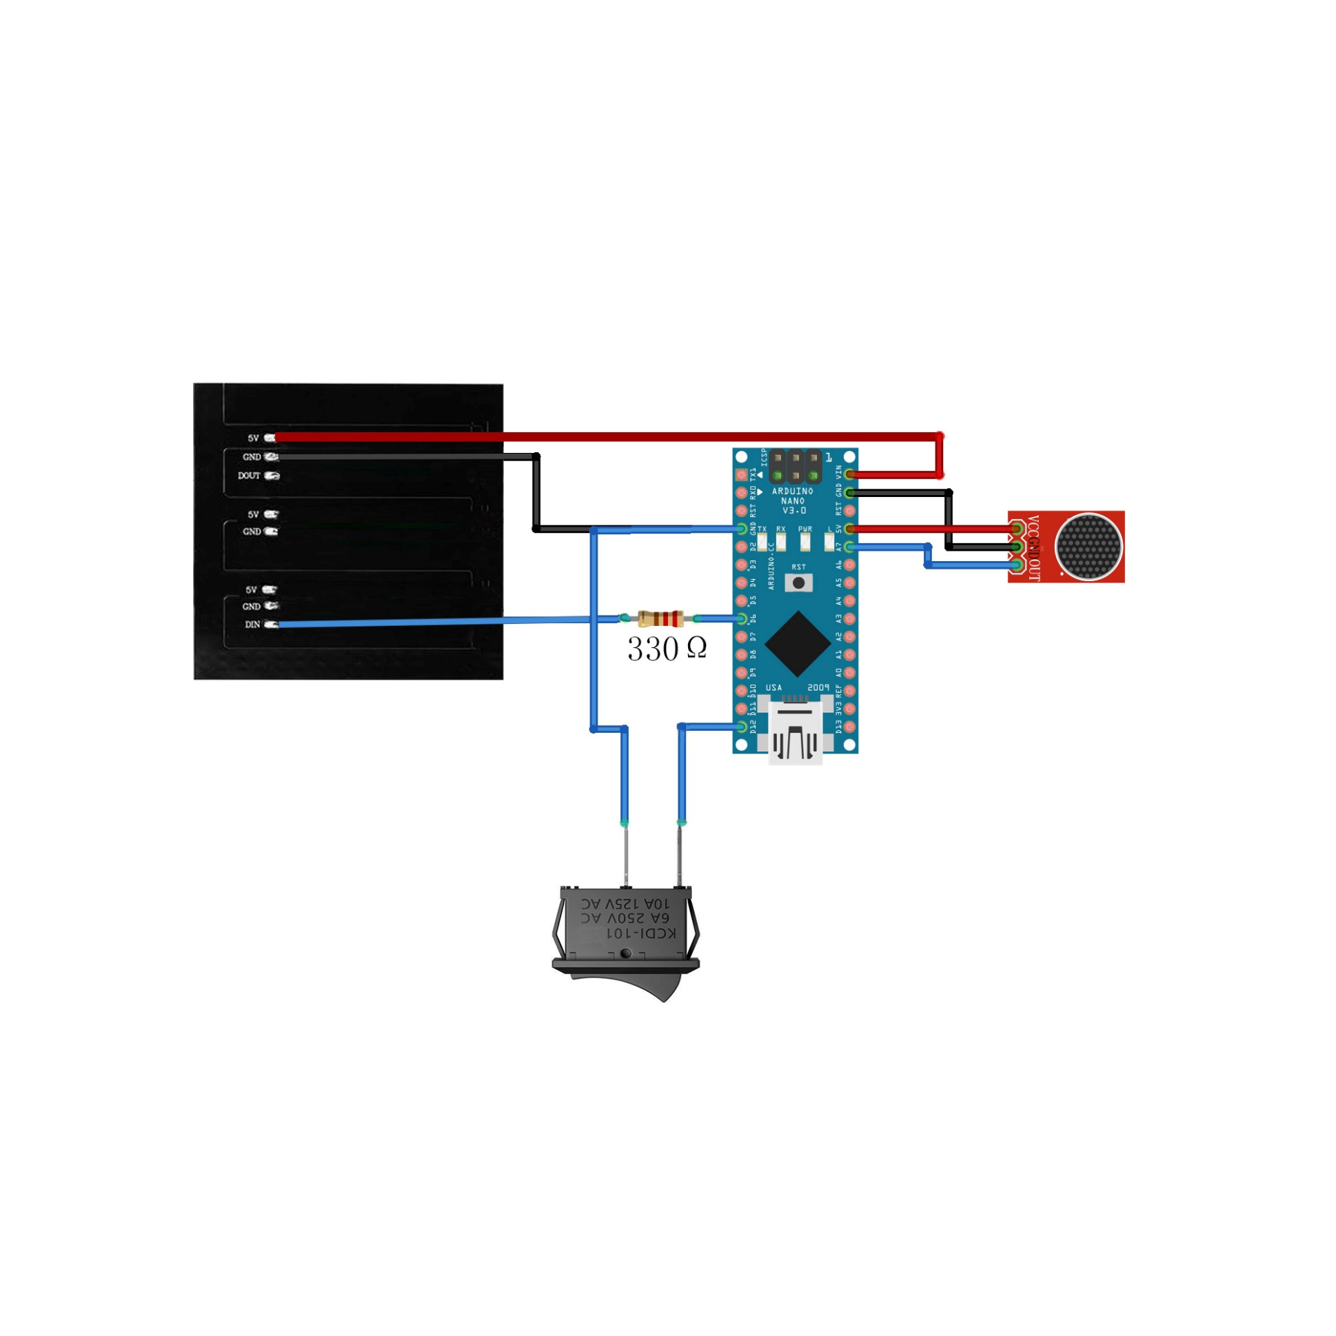

**Circuit connection:**

Led matrix 8x8 WS2812B DIN pin------------ 330Ω resistor

400-500Ω resistor-------------------------------- Arduino Nano D6 Pin

max4466 microphone VCC pin---------------- Arduino Nano 5V Pin

max4466 microphone GND pin---------------- Arduino Nano GND Pin

max4466 microphone OUT pin---------------- Arduino Nano A7 Pin

Led matrix 8x8 WS2812B 5V pin-------------- Arduino Nano VIN Pin

Led matrix 8x8 WS2812B GND pin----------- Arduino Nano GND pin

KCD1 switch--------------------------------------- Arduino Nano D12 pin

Arduino Nano GND pin-------------------------- KCD1 switch